

|  |  |
| --- | --- |
| **Name** | Omar Waled EL-Sayed Mahmoud |
| **ID** | 549 |
| **Sec** | 25 |
| **Group** | 5 |
| **Github Link** |  |
| **Github Page** |  |

|  |
| --- |
| **Examiners Committee** |
| Dr.Ahmed Bayoumi |
| Dr.Shady Elmashad |
| Dr.Abdelhamid Attaby |

***Computer Engineeering Role in COVID-19 Pandemic .***

By :

Omar Waled

“It has been an immense Pleasure to do this project . As it made me apply some of the skills I have been working on and writing a report about the topic that I’m Interested in and have been reading about for a quite long time “

***About the Website in the project***

The website consists of a **Main** **HTML** file :

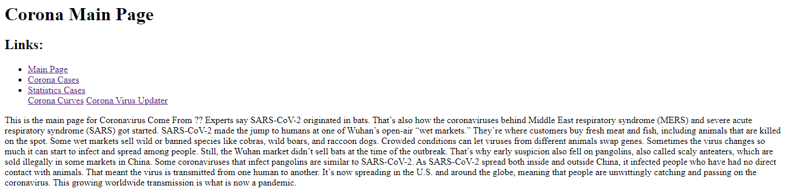

# Source Code :

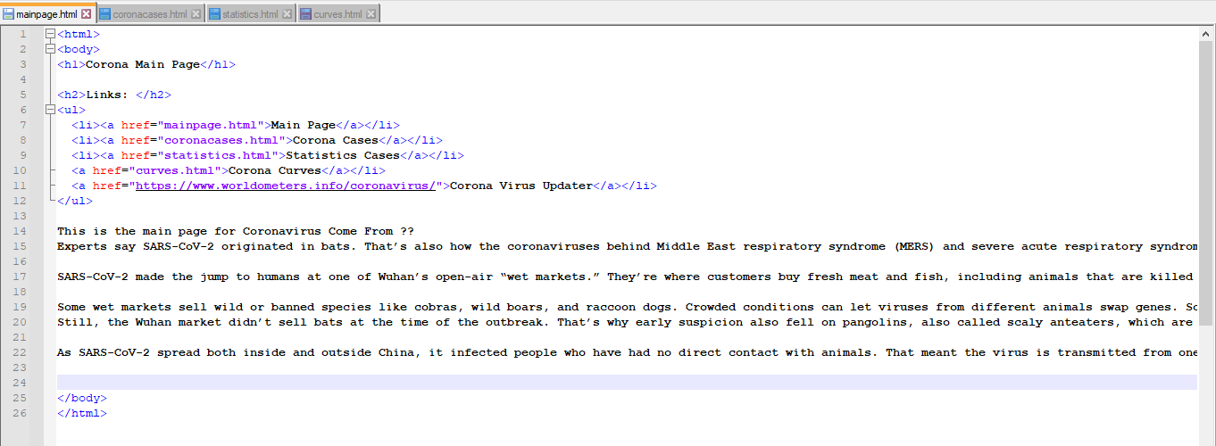

The website consists of **Corona Cases :**

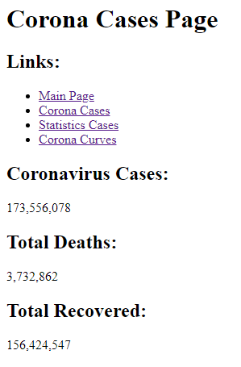

Source Code :

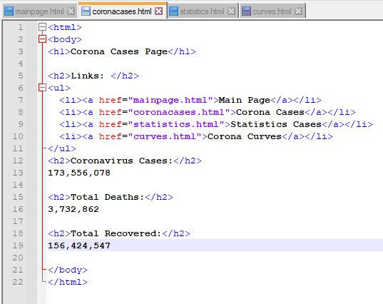

The website consists of a ***Statistics Cases*** in France,Turkey and Russia :

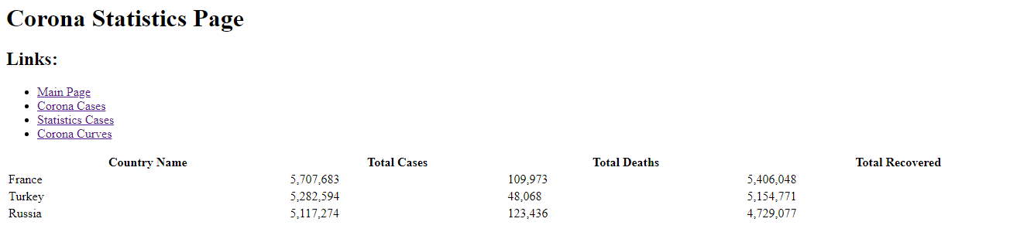

# Source code :

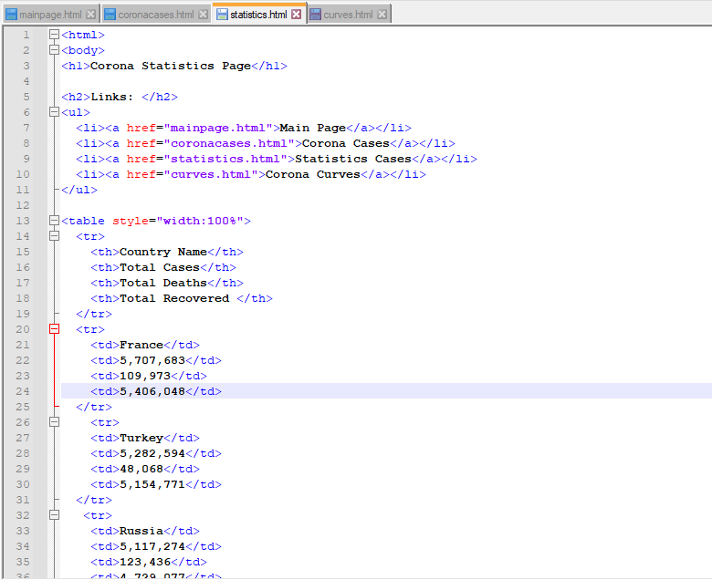

The website consists of **Corona Curves**  in France,Turkey and Russia :

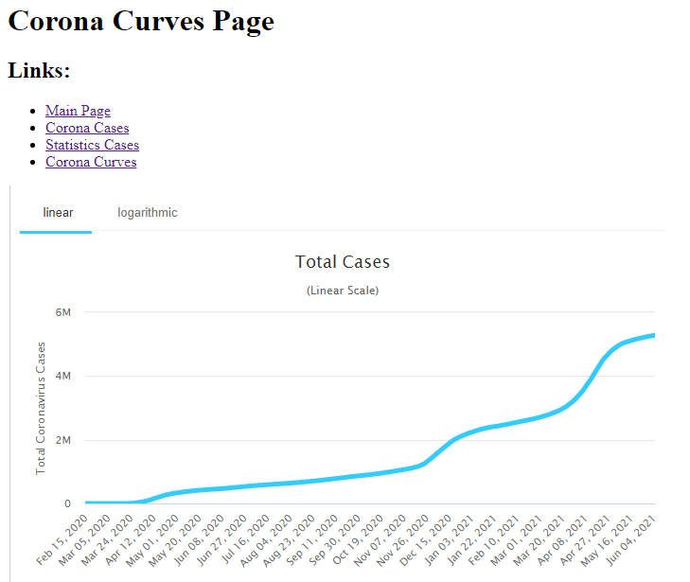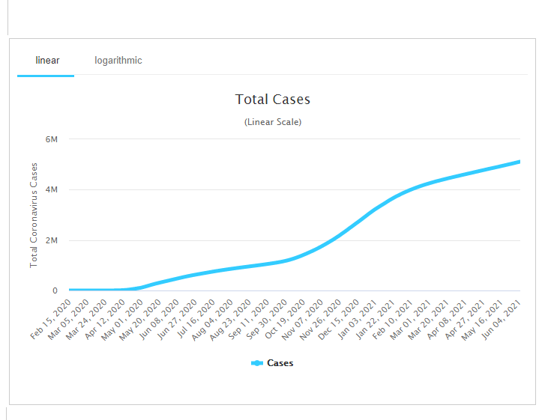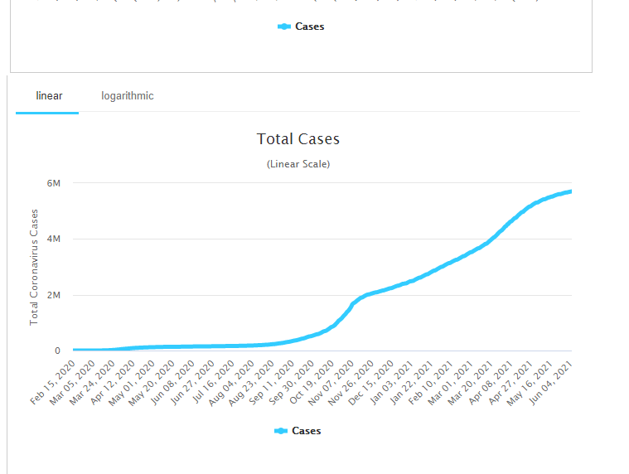

# Source code :

